COSC 3308 Design Programming Languages

Lab Assignment 1
Andrew Kalathra

Problem 1: Sales Profit Calculation
A company has determined that its annual profit is typically 23% of total sales. Write a program that prompts the user to enter the projected total sales amount, then calculates and displays the profit from that amount.
- Task 1a: Create an algorithm, pseudocode, and a graphical flowchart for this program.
- Task 1b: Draw the Software Development Life Cycle (SDLC) and indicate where the algorithm, pseudocode, and graphical flowchart fit into the SDLC process.
- Task 1c: Write the code using any programming language. Provide the executable program with comprehensive comments and suitable variable names.
- Task 1d: Include the program's output screenshot showing both input and output.
- Task 1e: Incorporate references to the online platforms or books used to complete this assignment.
- Profit Calculation
  - Creating an algorithm, pseudocode, and graphical flowchart
    - Algorithm:
//Get user input
"Enter projected total sales"
User Input --> TotSales
//Store user input
Profit = TotSales * 0.23
//Calculate
"Your profit is $" Profit
//Output
    - Pseudocode:
start
//Get User Input
print("Enter projected total sales")

double totSales = double(input)

//Calculations
double profit = totSales * 0.23

//Output
print("Your profit is $" + Profit)
end
    - Graphical flowchart:
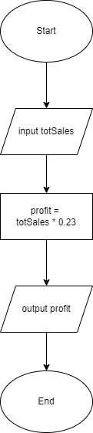
  - The Software Developmental Lifecycle:
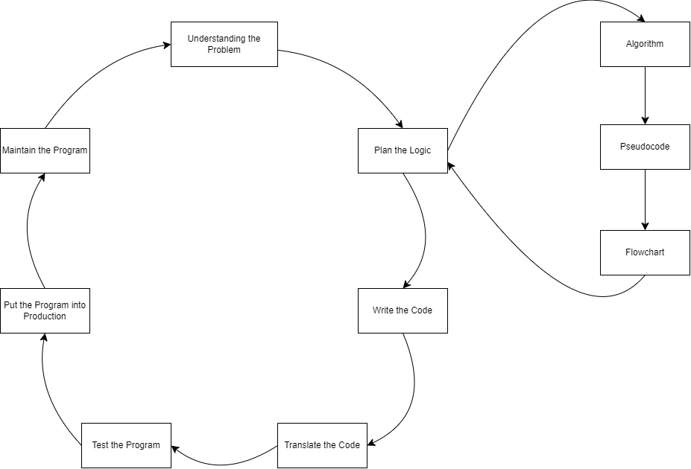
  - The Code:
    - 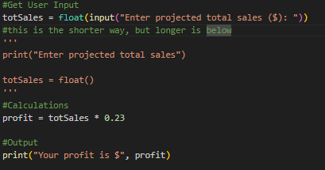
  - I/O:
  - References:
    - Week 1-2: Chapter 1 Slides, Design Programming languages, COSC-3308, Cengage, Dr. MD Masud Rana

Problem 2: Store Purchase Calculation
A customer in a store is purchasing five items. Write a program that asks for the price of each item, calculates the subtotal of the sale, the amount of sales tax (assume 7%), and the total amount. Follow the same structure as in Problem 1.
- Task 2a: Create an algorithm, pseudocode, and a graphical flowchart for this program.
- Task 2b: Research 4-6 Integrated Development Environments (IDEs) that include both interpreters and compilers, and 4-6 online debuggers such as onlinegdb.com.
- Task 2c: Write the code with comments using any IDE, such as Python, C, C++, Java, or MATLAB, and provide screenshots.
- Task 2d: Include the program's output screenshot showing both input and output.
- Task 2e: Provide references for the tools and resources used.

- Store Purchase
  - Creating an algorithm, pseudocode, and graphical flowchart
    - Algorithm:
//State Purpose
"Hello Customer, Ready for Checkout?"
"Enter Your 5 Item Prices Below"

//Go Through for loop and take in input
//add each to a sum variable
sum
for(i --> 5){
"Item " i = User Input
sum += input
}
//add a variable called subtotal for the
//total before tax
subtotal = sum

//add tax, add var called total
total = subtotal * 1.07

//Print the results
"Subtotal = " subtotal
"Total = " total

    - Pseudocode:
start
//State Purpose
print("Hello Customer, Ready for Checkout?")
print("Enter Your 5 Item Prices Below")

//Go Through for loop and take in input
//add each to a sum variable
double sum
for(i --> 5){
print("Item ", i, ": ")
sum += input()
}
//add a variable called subtotal for the
//total before tax
double subtotal = sum

//add tax, add var called total
double total = subtotal * 1.07

//Print the results
print("Subtotal = ", subtotal)
print("Total = ", total)
end
    - Graphical Flowchart:
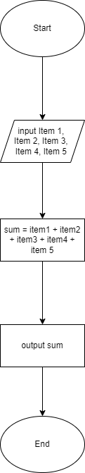
  - IDE, Compilers, Debuggers
    - IDE & Compilers:
      - IntelliJ: https://www.jetbrains.com/idea/
      - Eclipse: https://eclipseide.org/
      - NetBeans: https://netbeans.apache.org/front/main/index.html
      - Visual Studio: https://visualstudio.microsoft.com/
      - PyCharm: https://www.jetbrains.com/pycharm/
      - RubyMine: https://www.jetbrains.com/ruby/
    - Online Debuggers:
      - JS Bin: https://jsbin.com/?html,output
      - WriteCodeOnline: https://www.writephponline.com/
      - IDEOne: https://ideone.com/
      - CodeSandBox: https://codesandbox.io/
      - Online GDB: https://www.onlinegdb.com/
  - Code:
    - 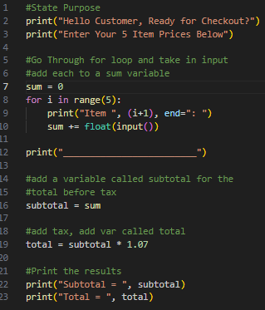
  - I/O: 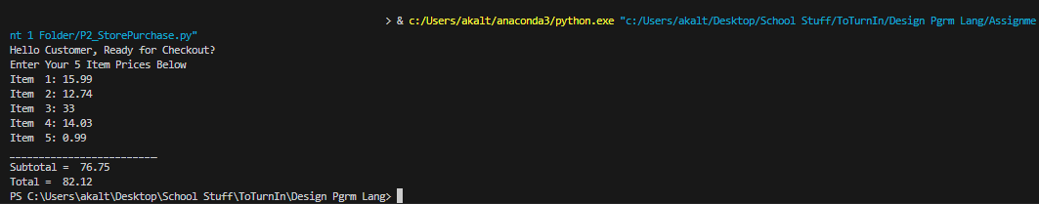
  - References:
    - Week 1-2: Chapter 1 Slides, Design Programming languages, COSC-3308, Cengage, Dr. MD Masud Rana
    - “Best Ide Software - A List of the Top 10.” KeyCDN, www.keycdn.com/blog/best-ide. Accessed 17 Sept. 2024.
    - “16 Great Websites to Test Code Online in 2024.” Turing, www.turing.com/blog/websites-tools-for-testing-your-codes. Accessed 17 Sept. 2024.

Problem 3: Meal Cost Calculation
Write a program that calculates the total cost of a meal purchased at a restaurant. The program should prompt the user to enter the charge for the food, then compute the amounts of an 18% tip and 7% sales tax. Display each of these amounts and the total.
- Task 3a: Create an algorithm, pseudocode, and a graphical flowchart for this program.
- Task 3b: Explore and describe 4-6 IDEs and online debugging tools.
- Task 3c: Use any IDE or online debugger to write and test your code, and provide the executable program with comprehensive comments and suitable variable names.
- Task 3d: Include the program's output screenshot showing both input and output.
- Task 3e: Provide real-world applications where this program can be used. Describe one application in detail, including a diagram.

- Meal Cost
  - Creating an algorithm, pseudocode, and graphical flowchart
    - Algorithm:
//State Purpose
"Welcome to Honest Burger!"
"How much did your food cost?"

//Get user input
User Input --> FoodCost

//tip calculation
Tip = FoodCost * 0.18

//tax cost
Tax = FoodCost * 0.07

//output results
"Your food cost " FoodCost
"Your tip costs" Tip
"Your tax costs" Tax
"Your total cost is" (FoodCost + Tip + Tax)
    - Pseudocode:
start
//State Purpose
print("Welcome to Honest Burger!")
print("How much did your food cost?")

//Get user input
foodCost = input()

//tip calculation
tip = foodCost * 0.18

//tax cost
tax = foodCost * 0.07

//output results
print("Your food cost ", foodCost)
print("Your tip costs ", tip)
print("Your tax costs ", tax )
print("Your total cost is", (foodCost + tip + tax))
end
    - Graphical Flowchart:
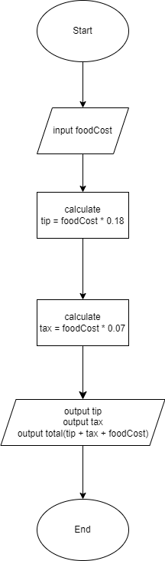
  - IDE, Compilers, Debuggers
    - Online Debuggers:
      - IDEOne: https://ideone.com/
      - Selenium: https://www.selenium.dev/
      - Android Studio: https://developer.android.com/studio
      - LLDB: https://lldb.llvm.org/
  - Code:
    - 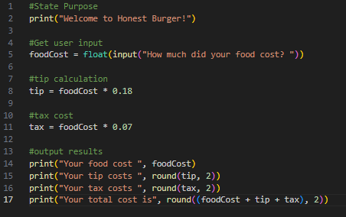
  - I/O: 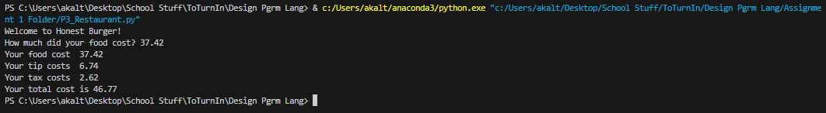
  - Real World Application and Diagram:
    - At a dining restaurant, cashiers can input this information on their computer. Usually, they would not enter the price, but rather the item the customer orders, which would connect to the database and give the price. This program would then take that price and show the necessary modifications. When the customer is ready to pay for their meal, they can glance over the prices. If something seems off to the customer, they may also run this program (on their personal device). At this point, they will have to manually enter their original meal’s price (as there is no database behind their program).
    - 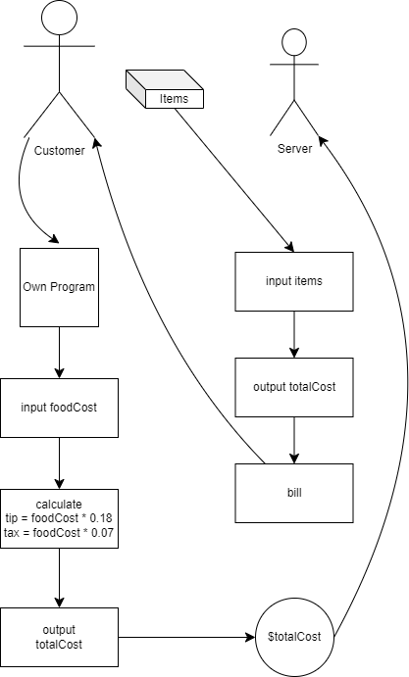
    - Another application would be at self checkouts in grocery stores. The register will scan the items, grab the data of the current price and deals contained in the database, and will add the necessary taxes.
  - References:
    - “16 Great Websites to Test Code Online in 2024.” Turing, www.turing.com/blog/websites-tools-for-testing-your-codes. Accessed 17 Sept. 2024.
    - "list of debuggers” prompt. Gemini, 2024.09.04, Google, September 17, 2024, https://gemini.google.com/
    - Week 1-2: Chapter 1 Slides, Design Programming languages, COSC-3308, Cengage, Dr. MD Masud Rana

Problem 4: Temperature Conversion
Write a program that converts Celsius temperatures to Fahrenheit. The program should ask the user for a Celsius temperature and then display the converted temperature in Fahrenheit. Familiarity with the formula F=$\frac{9}{5}$C+32 is required.
- Task 4a: Create an algorithm, pseudocode, and a graphical flowchart for this program.
- Task 4b: Use any IDE or online debugging tool to write and test your code, and provide the executable program with comprehensive comments and professional variable names.
- Task 4c: Include the program's output screenshot showing both input and output.
- Task 4d: List and explain 4-6 applications where temperature conversion is relevant.
- Task 4e: Provide a detailed description and diagram of one such application and share your experience.

- Temperature Conversion
  - Creating an algorithm, pseudocode, and graphical flowchart
    - Algorithm:
//State Purpose
"Give me a temperature in Celsius, "
"I'll give it to you in Fahrenheit"

//User Input
User Input --> Celsius

//conversion
Fahrenheit = (9 * Celsius / 5) + 32

//output
Celsius "Celsius is " Fahrenheit "Fahrenheit"
    - Pseudocode:
start
//State Purpose
print("Give me a temperature in Celsius, ")
print("I'll give it to you in Fahrenheit")

//User Input
double Celsius = input()

//conversion
Fahrenheit = (9 * Celsius / 5) + 32

//output
print(Celsius, "Celsius is ", Fahrenheit, "Fahrenheit")
end
    - Graphical Flowchart:
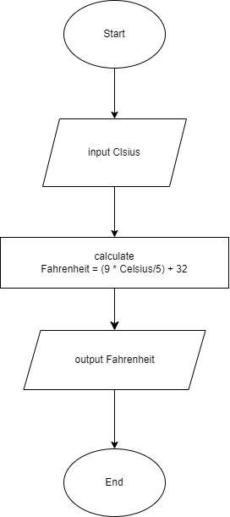
  - Code: 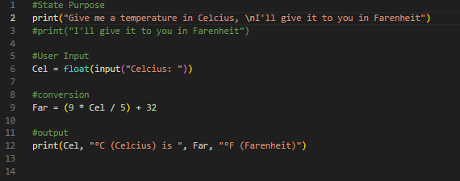
  - I/O: 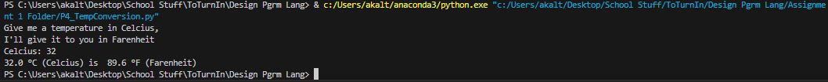
  - Real World Applications:
    - When making weather forecasts, it may be necessary to convert temperatures recorded by foreign devices to values you are comfortable with.
    - In science, °C is used as this is standard. When translating this to temperatures American’s are comfortable with and may understand better, this conversion is necessary.
    - When travelling to foreign countries that use °C, this program can be used to convert the temperature to Fahrenheit, which may be better understood.
    - In chemistry, using a variety of formulas requires either the use of °C or K (for Kelvin). Kelvin can only be found through °C (K = 273.15 + °C), so a conversion is necessary if the measurement is gained in °F.
    - In cooking, some dishes require specific temperatures for meats or dishes. If the measurement is gained in one scale, it can easily be converted through this program.
  - Description and Diagram:
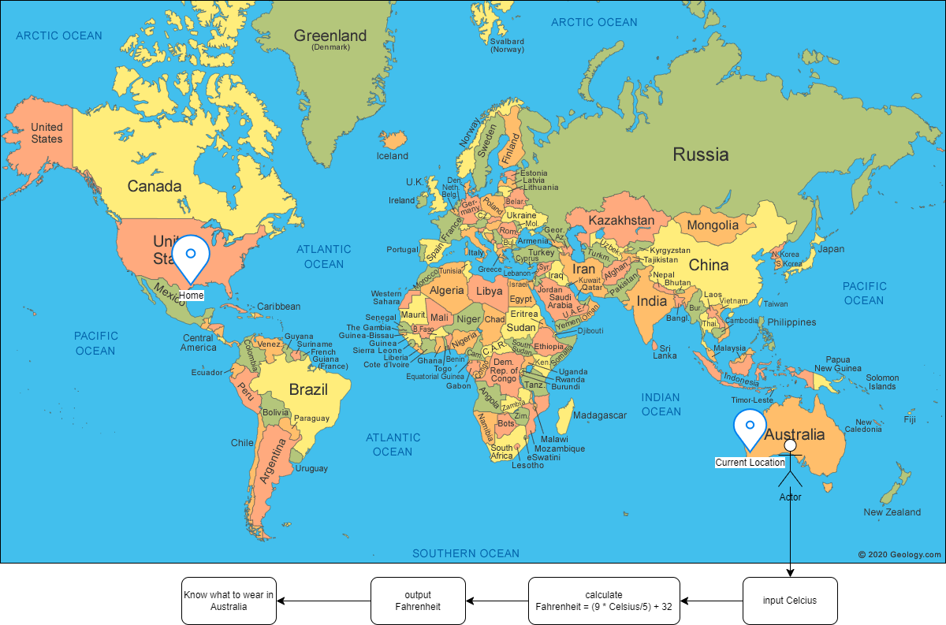
    - In this detailed diagram, we can see that the user is not where he calls himself home. In his homeland (America), he is used to Fahrenheit, whereas in his current location (Australia), they use Celsius. To know what to wear in this foreign climate, he can use the proposed program to know what the temperature is and plan accordingly.
  - References:
    - “World Map - Political - Click a Country.” Geology, geology.com/world/world-map.shtml. Accessed 17 Sept. 2024.
    - Week 1-2: Chapter 1 Slides, Design Programming languages, COSC-3308, Cengage, Dr. MD Masud Rana

Problem 5: Rectangle Area Comparison
Write a program that asks for the length and width of two rectangles, then compares their areas and tells the user which rectangle has the greater area or if their areas are the same.
- Task 5a: Create an algorithm, pseudocode, and a graphical flowchart for this program.
- Task 5b: Install one IDE, such as Python, C, C++, Java, or MATLAB, and include a screenshot that validates the installation.
- Task 5c: Write the code using the installed IDE, and provide screenshots showing the correct input and output.
- Task 5d: Write the code in a different language from Task 5c using another IDE or online debugger. Provide screenshots of correct input and output. For instance, if you used C in Task 5c, use Python for Task 5d or vice versa.
- Task 5e: Describe a real-world application where this type of problem is relevant. Provide a diagram and detailed explanation.

- Rectangle Area
  - Creating an algorithm, pseudocode, and graphical flowchart
    - Algorithm:
//State Purpose
"I can compare which of your "
"2 rectangles are bigger"

//user input
//Rectangle 1 dimensions:
User Input --> Rectangle 1 length
User Input --> Rectangle 1 width
//Rectangle 2 dimensions:
User Input --> Rectangle 2 length
User Input --> Rectangle 2 width

//Calculations for area
Area1 = Rectangle 1 length * Rectangle 1 width
Area2 = Rectangle 2 length * Rectangle 2 width

//Print output
"Rectangle 1 has an area of " Area1
"Rectangle 2 has an area of " Area2
if (Area1 > Area2){
"Rectangle 1 is bigger"
}else{
"Rectangle 2 is bigger"
}
    - Pseudocode:
start
//State Purpose
print("I can compare which of your ")
print("2 rectangles are bigger")

//user input
//Rectangle 1 dimensions:
Rectangle1Length = input()
Rectangle1Width = input()
//Rectangle 2 dimensions:
Rectangle2Length = input()
Rectangle2Width = input()

//Calculations for area
double Area1 = Rectangle1length * Rectangle1width
double Area2 = Rectangle2length * Rectangle2width

//Print output
print("Rectangle 1 has an area of ", Area1)
print("Rectangle 2 has an area of ", Area2)
if (Area1 > Area2){
print("Rectangle 1 is bigger")
}else{
print("Rectangle 2 is bigger")
}
end
    - Graphical Flowchart:
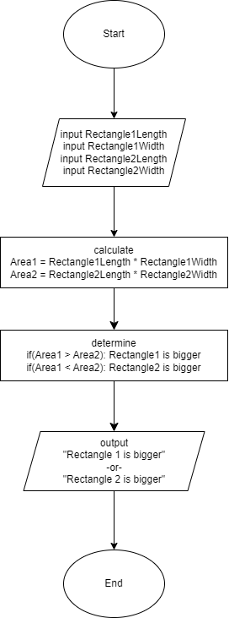
  - Install an IDE:
    - I have installed Jupyter notebook alongside Anaconda. As follows is proof of the file path on my PC:
    - 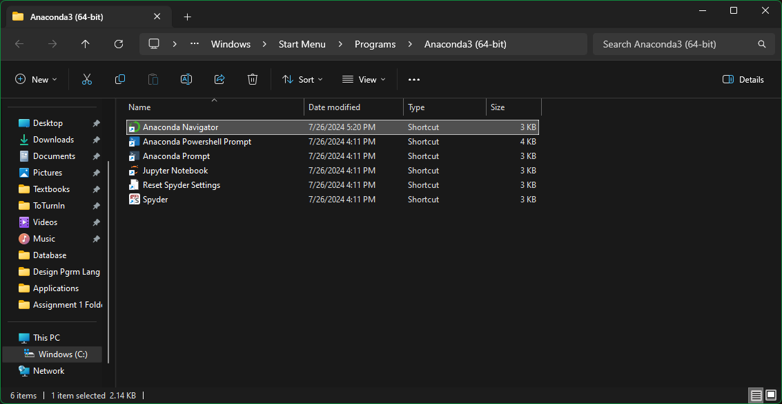
  - Code in Python: 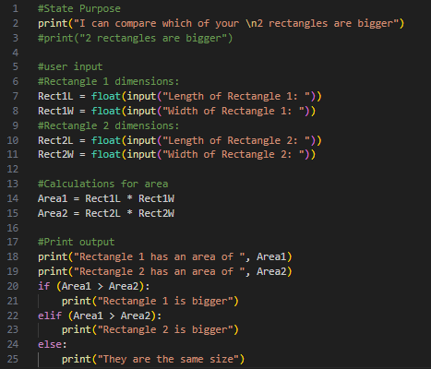 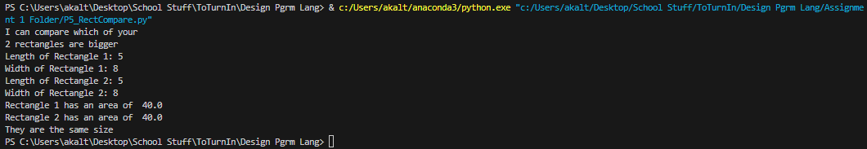
  - Code in Java: 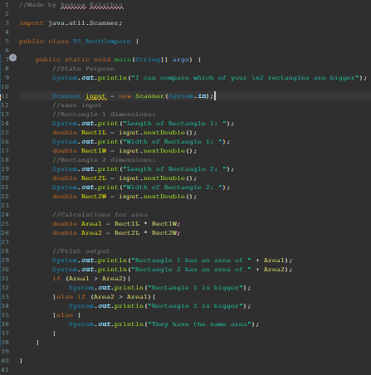 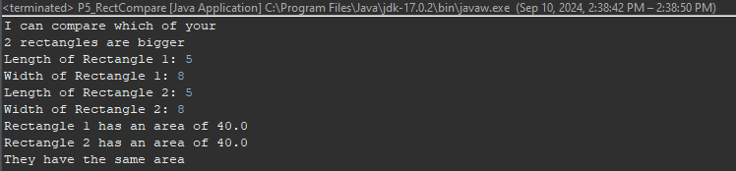
  - Real World Applications, Description and Diagram: When making a house, decoration and modelling may need to take into consideration the approximate sizes of the rooms. Knowing which rooms are larger by volume is helpful and can easily be given by just inputting the dimensions of the room.
  - References:
    - Week 1-2: Chapter 1 Slides, Design Programming languages, COSC-3308, Cengage, Dr. MD Masud Rana

Problem 6: Create Your Own Problem
In the Software Development Life Cycle (SDLC), problem definition is crucial. This problem can originate from business needs or personal interest. The requirements, timeframe, security, and features often involve trade-offs between developers and stakeholders. Develop a problem based on your interests, skills, and professional goals. You may choose to complete the following tasks as examples:
- Task 6a: Explain why the problem is interesting and unique.
- Task 6b: Outline the key features of the problem statement and include a graphical representation.
- Task 6c: Discuss how security can be integrated into the problem or the SDLC, or both.
- Task 6d: Implement a solution using Python or another programming language. Provide comprehensive comments, output screenshots, and use tools such as CodeGDB or Jupyter Notebook.
- Task 6e: Include an executable program with comments and outputs. Incorporate references and resources used. Demonstrate the real-world applicability of the program with diagrams and explanations.

- Making a Problem
  - The problem and description: In the medical field, patients may not know all the numbers that are considered average, whether that be for how fast a heart rate is meant to be, how a range for a blood pressure, or even for balancing their weight on a manageable level. Taking this into account, the issue I want to address is converting the numbers seen into a discussion the patient will understand. Specifically, I will try focusing on heart values.
  - Key features and Graphical Representation:
    - Key features include the heart rate and blood pressure for the input’s, and the output key features are the estimates and links.
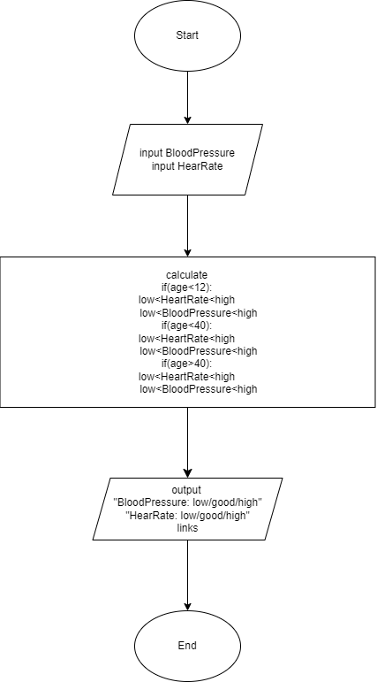
  - Security Integration: A minor security integration that can be added to this program is checkers. This would take the form of checking what was being put in, such as the numbers themselves. This would make it so that bad inputs would not give false information. Alongside this, while this program runs on a personal computer, the data entered is not stored, so this is a natural security integration.
  - Code: 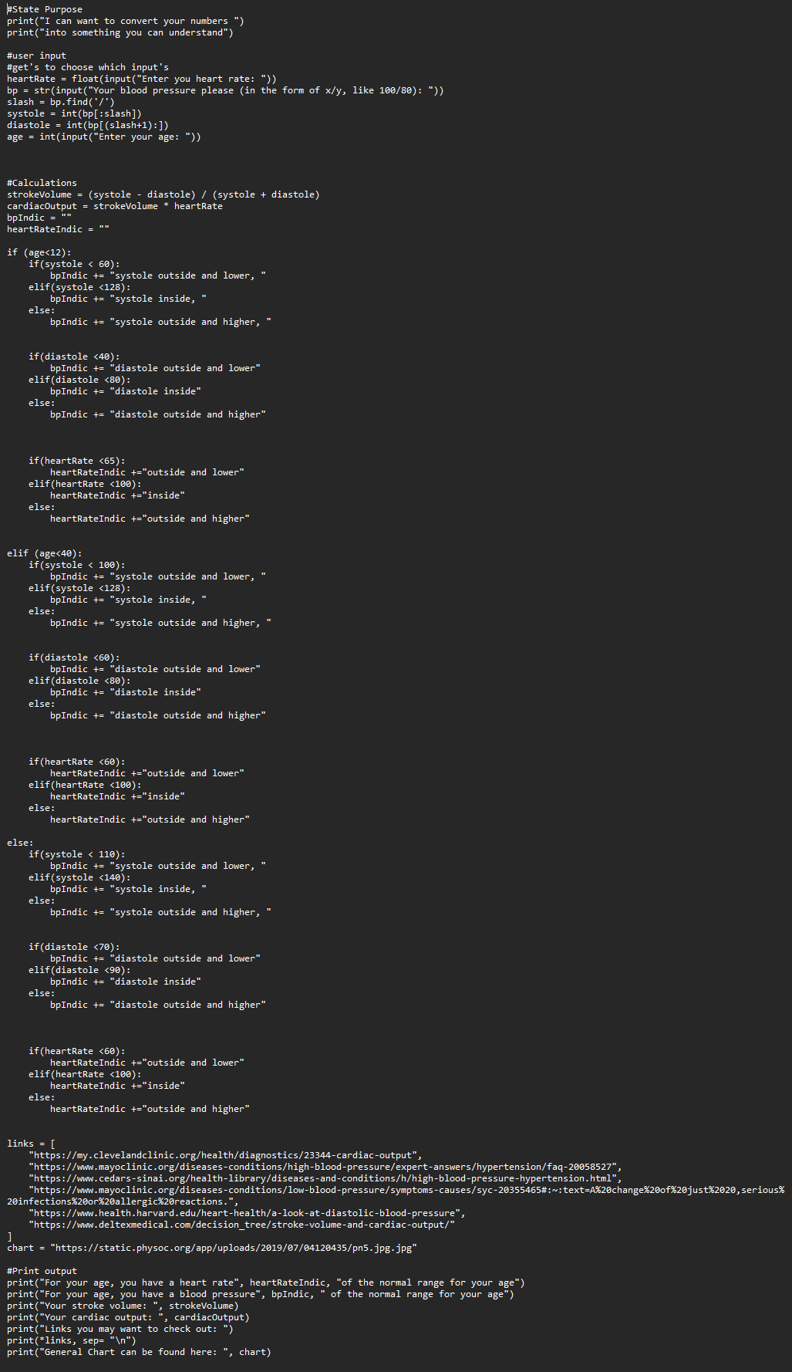
  - I/O, References, Real-World Application, Diagrams & Explanations:
    - I/O: 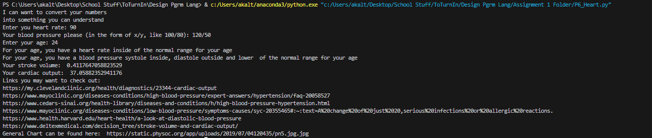
    - Real-World Application: In the real world, this would help patients bring up concerns to their physicians, which may lead to fruitful discussions over health and health changes for the better.
    - Diagram:
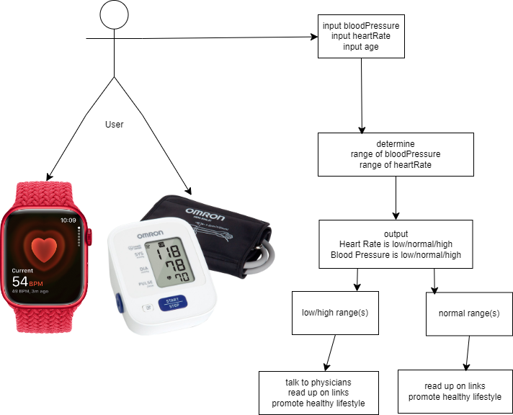
    - Explanations: The User (patient) may monitor their heart rate and blood pressure using common devices now (such as apple watches, blood pressure monitors, or other such devices). Unable to decipher the number’s meaning, this program will take in the input, calculate the necessary values, and spit out helpful links as well as stating where they are. The patient can then bring this to a physician to verify.
  - References
    - Week 1-2: Chapter 1 Slides, Design Programming languages, COSC-3308, Cengage, Dr. MD Masud Rana
    - “Omron 3 Series Automatic Upper Arm Blood Pressure Monitor Black/White BP7100.” Best Buy, www.bestbuy.com/site/omron-3-series-automatic-upper-arm-blood-pressure-monitor-black-white/6370324.p?skuId=6370324. Accessed 17 Sept. 2024.
    - “Monitor Your Heart Rate with Apple Watch.” Apple Support, support.apple.com/en-us/120277. Accessed 17 Sept. 2024.
    - professional, Cleveland Clinic medical. “Understanding Cardiac Output and What It Means.” Cleveland Clinic, 1 May 2024, my.clevelandclinic.org/health/diagnostics/23344-cardiac-output.
    - “Isolated Systolic Hypertension: A Health Concern?” Mayo Clinic, Mayo Foundation for Medical Education and Research, 25 Apr. 2024, www.mayoclinic.org/diseases-conditions/high-blood-pressure/expert-answers/hypertension/faq-20058527.
    - “Articles.” Cedars, www.cedars-sinai.org/health-library/diseases-and-conditions/h/high-blood-pressure-hypertension.html. Accessed 17 Sept. 2024.
    - “Low Blood Pressure (Hypotension).” Mayo Clinic, Mayo Foundation for Medical Education and Research, 13 June 2024, www.mayoclinic.org/diseases-conditions/low-blood-pressure/symptoms-causes/syc-20355465#:~:text=A%20change%20of%20just%2020,serious%20infections%20or%20allergic%20reactions.
    - Solan, Matthew. “A Look at Diastolic Blood Pressure.” Harvard Health, 1 Apr. 2022, www.health.harvard.edu/heart-health/a-look-at-diastolic-blood-pressure.
    - Stroke Volume and Cardiac Output, www.deltexmedical.com/decision_tree/stroke-volume-and-cardiac-output/. Accessed 17 Sept. 2024.
    - “Cardiac Output Diversity.” The Physiological Society, 23 Dec. 2019, www.physoc.org/magazine-articles/cardiac-output-diversity-are-children-just-small-adults/.

